New data shows on-time container shipping suffers biggest drop in 5 years

Stuart Chirls, Thursday, September 03, 2026
Original Article: https://www.freightwaves.com/news/new-data-shows-on-time-container-shipping-suffers-biggest-drop-in-5-years
Articles Reproduced by Permission of FreightWaves

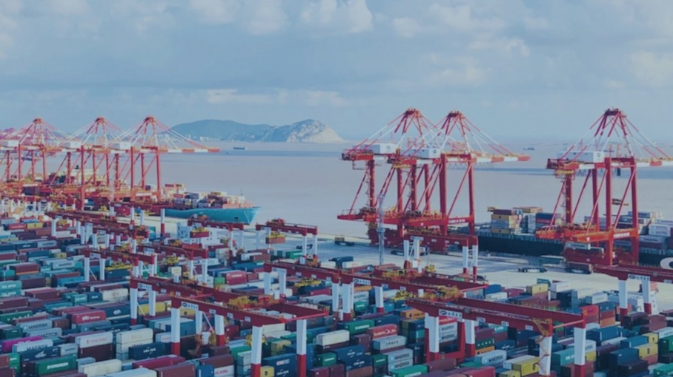
Port of Shanghai. (Photo: Shanghai International Port Group/FreightWaves)

World’s busiest box hub post worst on-time record ever

Severe weather disturbances in Asia hit global container shipping’s on-time performance in July.

Global container vessel schedule reliability dropped to 56.4% in July 2026, a decline of 6.1% from June, according to a new report from Sea Intelligence.

It’s the sharpest single‑month decline since January 2021, the Copenhagen-based analyst said.

At the same time, the average delay for late vessel arrivals climbed to 6.06 days, up more than a half-day m/m.

This pronounced drop was driven primarily by congestion across major Asian ports, said Alan Murphy, CEO of Sea-Intelligence. “All 14 of the region’s busiest ports experienced a decrease in on‑time vessel arrivals.”

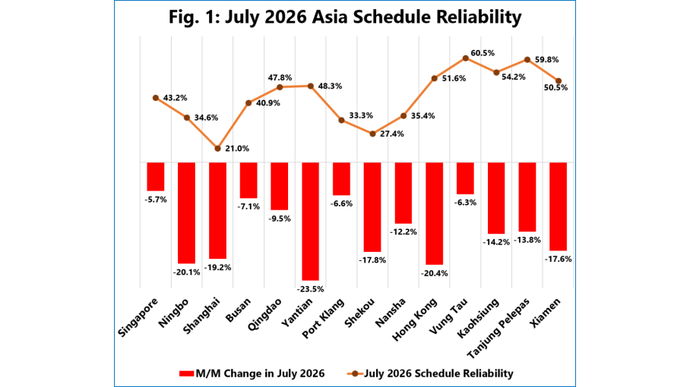
(Chart: Sea Intelligence)

Yantian took the hardest hit with schedule reliability plummeting 23.5 percentage points (pp) to 48.3%. Hong Kong dropped by 20.4 pp to 51.6%, and Ningbo saw reliability fall by 20.1 pp to 34.6%.

The report called the situation in Shanghai “particularly alarming.” Following a steep decline of 19.2 pp, just 21% of container vessels arrived at the world’s busiest port on time in July 2026.

“Outside of extreme pandemic‑era supply chain disruptions, schedule reliability in Shanghai has never dropped this low in 14 years of recorded data,” Murphy said.

Less severe schedule unreliability in July spread to other Asia hubs.

Singapore posted on-time reliability of just 43.2% after a 5.7 pp drop from June. Port Klang, Malaysia, was weaker at 33.3%, and Busan, South Korea fell to 40.9%.

The report observed that with the region’s busiest ports operating with more than half of their incoming vessels delayed, the backlog will cascade through the maritime network, likely triggering a new wave of delays for critical headhaul trade lanes in the coming months.

